

**Department of Psychology**

**Research Proposal**

**The Influence of Mindfulness Meditation Training**

**on Attention to Internal Experience**

By: Omer Dar, B.A.

Supervised by: Prof. Amit Bernstein, Ph.D.

The University of Haifa,

Department of Psychology

XXXXXX 2019

# Abstract

# Introduction

# **Background & Significance**

There is a growing body of evidence linking mindfulness meditation training (MMT) to wellbeing, reduced stress-related mental health problems and their chronicity and relapse, as well as related salutary intra- and inter-personal processes (Bernstein, Vago, & Barnhofer, 2019; Chiesa & Serretti, 2011; Creswell, 2017; Goldberg et al., 2018; Grossman, Niemann, Schmidt, & Walach, 2004; Hofmann, Sawyer, Witt, & Oh, 2010). In turn, there is fast-growing interest in the mechanisms that may explain or mediate these salutary and curative effects of mindfulness training (Gu, Strauss, Bond, & Cavanagh, 2015). Attention represents a particularly important focus of such theory and research. Meditation practices that directly target attentional processes are integral to MMT (Bishop et al., 2004; Hölzel et al., 2011; Lutz, Jha, Dunne, & Saron, 2015; Shapiro, Carlson, Astin, & Freedman, 2006a). Yet, empirical evidence directly linking MMT practices and their salutary effects to targeted attention processes is mixed and, when observed, effects are modest (Chiesa, Calati, & Serretti, 2011; Lao, Kissane, & Meadows, 2016; Malinowski, 2013; Y. Y. Tang, Hölzel, & Posner, 2015; Vago, Gupta, & Lazar, 2019). The proposed dissertation research seeks to explore this paradox – the discrepancy between theory regarding the essential role of attention change processes in MMT versus extant limited and mixed empirical evidence of such effects. Specifically, the proposed dissertation is focused on one possible explanatory framework that may, in part, account for this discrepancy – the field’s focus on *external* environmental stimuli or objects of attention (e.g., visual attention) rather than *internal* stimuli or objects of attention (e.g., thoughts, bodily sensations) targeted by MMT (Chiesa et al., 2011; Cusens, Duggan, Thorne, & Burch, 2010; Josefsson & Broberg, 2011).

Before laying out the proposed research aims and methods, we first review the following literatures and ideas important to the proposed research: (1) Buddhist and contemporary thinking on mindfulness as an attentional training practice (2) Contemporary models of attention and MMT; (3) Empirical findings linking MMT to attentional processes; (4) External versus internal attention in MMT; (5) MMT, mind and internal attention: Theory, empirical findings, and emerging methods; (6) MMT, body and interoceptive attention: Theory, empirical findings, and emerging methods.

1. **Buddhist and contemporary thinking on mindfulness as an attentional training practice**

MMT refers to a variety of meditation practices that target attention (Lutz, Slagter, Dunne, & Davidson, 2008). The Buddhist and contemporary definitions of MMT highlight the role of attention and many scholars conceptualize MMT as a cognitive-attentional training (Bishop et al., 2004; Hölzel et al., 2011; Lutz et al., 2015; Shapiro et al., 2006a). The Pali word ***‘sati’*** has been translated to mean 'mindfulness’ and understood to mean ‘lucid awareness’(Bodhi, 2011). The canonical *Satipatthana Sutta*, refers to the four establishments of mindfulness, each referring to experience to which one may attend in mindfulness practice: body (e.g. breath, pain), feelings (e.g., pleasant, unpleasant, neutral feeling), states of mind (e.g., thought, concentration ), and experiential states conductive to wisdom (e.g., conditions leading to doubt or equanimity ) (Analayo, 2019; Bodhi, 2011).Thus, MMT entails orienting of attention to specific experiential states. Furthermore, the *Satipatthana Sutta* also explain that MMT characterizes key features of attending to these experiential states - such as with “continuity of awareness" (Anālayo, 2003, p. 267) and with a capacity “for stopping rash interference” (Nyanaponika, 1968, p. 25). In the contemporary secular or “mainstream” contemplative literature, mindfulness is defined as paying attention to the present moment experience without evaluation or judgment to what is being observed (Kabat-Zinn, 2011). Despite an ongoing debate regarding definitions of mindfulness (Grossman, 2019; Van Dam et al., 2018), it is important here to highlight that *attention* transcends these conceptual perspectives in its definitive and functional role in mindful awareness and mindfulness meditation (Bishop et al., 2004; Brown & Ryan, 2003; Kabat-Zinn, 2011; Slagter et al., 2007).

1. **Contemporary models of attention change processes in MMT**

One way to think about the theorized role(s) of attentional processes in MMT is through contemporary cognitive models of sustained attention, attentional selection, and a number of executive functions often referred to collectively as attentional control (Bishop et al., 2004; Chiesa et al., 2011; Functional, 2012; Hölzel et al., 2011; Lao et al., 2016; Lutz et al., 2015; Malinowski, 2013; Shapiro, Carlson, Astin, & Freedman, 2006b; Y. Y. Tang et al., 2015). First, sub-served mainly by the alerting network, sustained attention is the ability to maintain a state of vigilance over a prolonged period of time. Second, sub-served mainly by the orienting network, attentional selection refers to the preferential or biased allocation of limited resources of attention to certain information from multiple competing sensory stimuli. Third, sub-served mainly by the executive network, attentional control refers to cognitive functions that underlie monitoring and regulation of attentional focus. These include conflict monitoring, disengagement from an object, mental set shifting and inhibition (Miyake et al., 2000; Petersen & Posner, 2012; Posner, 1990).

To begin to illustrate the theorized role(s) of these attention processes in MMT, it is useful to differentiate between focused attention and open monitoring meditation practices (Chiesa & Malinowski, 2011; Lutz et al., 2008). Focused attention or concentration entail sustained attention on a specific selected object of experience (e.g., breathe). Here, attentional control, such as via the inhibition of wandering of attention, is needed to maintain sustained focus on a given object. Attentional control is also important to when one’s attention is no longer focused on the selected object of experience to some other off-task mental process (e.g., mind wandering, mental time travel, self-referential processing). Then, the ability to disengage attention from that object and to re-orient and select the chosen object is essential. Open monitoring practices are thought to entail moment by moment attention to anything that occurs in experience (e.g., thoughts, body sensations), without selective focus and sustained focused attention on a single object of experience (e.g., breathe) (Grabovac, Lau, & Willett, 2011; Lutz et al., 2015; Malinowski, 2013). Attention control is also important to open monitoring but serves a somewhat different function(s) relative to focused attention. In open monitoring, XXXXXXX while monitoring faculty and switching between objects are emphasized. For example, in open monitoring attention is deployed and re-deployed from one object of experience to the next (i.e. switching) while inhibiting sustained focused attention on any object of experience, even salient objects that would normally capture sustained focused attention (Hölzel et al., 2011; Lutz et al., 2015, 2008).

1. **Empirical findings linking MMT to attentional processes**

Scholarship on MMT and attention to-date has not been limited to theory alone – a growing body of empirical research has explored the theorized role(s) of attention in MMT (see (Chiesa et al., 2011; Gallant, 2016; Lao et al., 2016; Malinowski, 2013; Y. Y. Tang et al., 2015; Vago et al., 2019) for a review). One set of studies examined **subjective experience of attention via self-report.** Broadly**,** meditators report better attentional abilities relative to non-practitioners (Hölzel et al., 2011; Moore & Malinowski, 2009; Y.-Y. Tang et al., 2007). For example, meditators report that meditation practice enable them to focus their attention for an extended period of time, and distractions disturb this focus less frequently during formal meditation practice and in everyday life (Barinaga, 2003). Whereas experienced meditators trained to observe their own minds may be more valid reporters as to the subjective experience of their attentional behavior, it is likely that most people are not (Barinaga, 2003; Grossman, 2011; Van Dam et al., 2018). Consequently, cognitive-experimental or behavioral tasks designed to experimentally measure and quantify attention processes may be a more optimal means to study attention in MMT.

Another body of work entails **cross-sectional between-group studies** – most often comparing experienced meditators to novices or non-practitioners. These studieshave documented that experienced meditators demonstrate superior performance (i.e., sustained attention, attentional selection and attentional control) relative to non-meditators on a number of tasks ((Chiesa, Serretti, & Jakobsen, 2013; Gallant, 2016; Malinowski, Moore, Mead, & Gruber, 2017; Y. Y. Tang et al., 2015). First, a number of studies have documented between-group differences in sustained attention (e.g., Wilkins’ Counting Test; Valentine & Sweet, 1999); Attentional Blink, (Leeuwen, Müller, & Melloni, 2009); Change Blindness Flickering Task, (Hodgins & Adair, 2010)), though others have not reported such differences (e.g., SART, (Josefsson & Broberg, 2011)). Second, a number of studies have documented differences with respect to attentional selection (e.g., Global-local task (van Leeuwen, Singer, & Melloni, 2012); Attention network task (ANT) (Gielen, Speckens, Giommi, van den Hurk, & Barendregt, 2009); Selective attention task (Hodgins & Adair, 2010)), though others have not (Global-Local Task, (Chan & Woollacott, 2007)). Third, between-group differences have also been observed with respect to attentional control (i.e. conflict monitoring, inhibition, switching) (Stroop, (Chan & Woollacott, 2007; Moore & Malinowski, 2009); Ambiguous image perspective-switching task (Hodgins & Adair, 2010); ANT before intervention (A. Jha, Krompinger, & Baime, 2007)), though here too, other studies have not observed significant differences between meditators and non-meditators (e.g., ANT, (Gielen et al., 2009); Stroop, (Josefsson & Broberg, 2011). Although important to document associations between meditation and attention processes, causal associations cannot be inferred from such effects. Indeed, cross-sectional between-group differences may be alternatively accounted for by differences between those that initiate and maintain a meditation practice and those that do not (Chiesa et al., 2011).

To more directly test casual relations between MMT and attention change processes, investigators have conducted a variety of **intervention studies** (see (Chiesa et al., 2013; Gallant, 2016; Lao et al., 2016; Malinowski, 2013; Y. Y. Tang et al., 2015).These studies have examined the effects of brief experimental manipulations of mindfulness, mindfulness-based interventions (MBIs), as well as “higher-dose” MMT retreats. Briefly, in contrast to cross-sectional between-group studies comparing meditators to non-meditators, intervention studies have yielded less conclusive, mixed effects of modest magnitude (Chiesa et al., 2011; Gallant, 2016; Lao et al., 2016; Y. Y. Tang et al., 2015; Vago et al., 2019). **First**, **effects of brief experimental manipulations** of mindfulness have been observed with respect to sustained attention (e.g., SART ,(Mrazek, Smallwood, & Schooler, 2012; Rahl, Lindsay, Pacilio, Brown, & David Creswell, 2017); ANT, (Polak, 2009)), selective attention (Flanker Task, (Norris, Creem, Hendler, & Kober, 2018) and attentional control (e.g. Stroop (Wenk-Sormaz, 2005); ANT, (Norris et al., 2018)). Notably, a larger number of studies have reported null effects of these brief mindfulness manipulations with respect to all studied attentional processes (e.g., Metronome Response Task (MRT),(Banks, Welhaf, & Srour, 2015) ; ANT, (Polak, 2009; Y.-Y. Tang et al., 2007), Stroop, (Basso, Mchale, Ende, Oberlin, & Suzuki, 2019; Moore, Gruber, Derose, & Malinowski, 2012)). **Second**, **effects of MBIs** (mostly MBSR or MBCT) have been observed with respect to sustained attention (e.g., ANT; (Oken et al., 2010); SART;(A. P. Jha et al., 2015; Meland et al., 2015)); Continuous Performance Test (CPT), (Cusens et al., 2010);Sustained Attention Task (Nicole D. Anderson & Mark A. Lau, 2007), attentional selection, (e.g., ANT, (Becerra, Dandrade, & Harms, 2017; Felver, Tipsord, Morris, Racer, & Dishion, 2017; A. Jha et al., 2007), The D2 Test Of Attention, (Jensen, Vangkilde, Frokjaer, & Hasselbalch, 2012), Dot-Probe Task with for bias to pain (Garland & Howard, 2013; Vago & Nakamura, 2011), Negative Affective Priming Task (NAP) (De Raedt et al., 2012) and attentional control (e.g., ANT, (Becerra et al., 2017; Felver et al., 2017; Zylowska et al., 2008); Emotional Stroop (Malinowski et al., 2017); Stroop (Oken et al., 2010; Rodriguez Vega et al., 2014). Yet, a large number of studies have reported null effects of MBIs on some or all measured attentional processes (e.g., ANT, (Becerra et al., 2017; Felver et al., 2017; Oken et al., 2010; van den Hurk et al., 2012; Zylowska et al., 2008); Stroop, (Jensen et al., 2012; Nicole D. Anderson & Mark A. Lau, 2007), CPT (MacCoon, MacLean, Davidson, Saron, & Lutz, 2014; Rodriguez Vega et al., 2014). **Finally, effects of MMT retreats** are the most consistent and robust. Effects of retreats have been observed with respect to sustained attention (e.g., ANT, (Elliott, Alan Wallace, & Giesbrecht, 2014; A. Jha et al., 2007); Internal Switching Task (IST); (Chambers, Lo, & Allen, 2008), Digit-Symbol Test (Kozasa et al., 2015), Sustained-Attention Task, (MacLean et al., 2010),attentional selection (e.g., Attentional Blink, (Slagter et al., 2007);Dichotic Listening Task, (Lutz et al., 2008)), and attentional control (ANT, (Elliott et al., 2014). Yet, even in the context of these high-dose MMT studies, a few studies have reported null effects on attentional control (e.g., ANT, (A. Jha et al., 2007); Self Shifting Task, (Cohen, Jensen, Stange, Neuburger, & Heimberg, 2017); IST - switching capacities (Chambers et al., 2008)).

In addition to these mixed findings of MMT and attentional change processes, there is a very limited body of research testing the putative mediating role of attention with respect to MMT salutary outcomes (e.g., well-being, mental health, stress-buffering effects). Most MMT-attention studies have not tested or reported findings regarding the associations between attention change and mental health outcomes of MMT (e.g., (Chan & Woollacott, 2007; Gielen et al., 2009; Hodgins & Adair, 2010; A. P. Jha et al., 2015; Leeuwen et al., 2009; Lutz et al., 2009; MacCoon et al., 2014; Malinowski et al., 2017; Rahl et al., 2017; Y.-Y. Tang et al., 2007; Valentine & Sweet, 1999; Wenk-Sormaz, 2005). Moreover, among studies which measured outcomes by self-report questionnaires in addition to cognitive attentional task, some found changes with measures of mental health and well-being in mindfulness group, but did not find changes in components of attention measured by cognitive tasks (Cohen et al., 2017; Cusens et al., 2010; van Aalderen et al., 2012). Thus, the association between attentional change processes and distal outcomes is unlikely to be as theorized in these studies. On the other hand, a few studies found expected associations between measures of attentional tasks and mental health outcomes following MMT such as depression symptoms (Beck Depression Inventory, (Chambers et al., 2008; De Raedt et al., 2012), negative affect (PANAS, (Mrazek et al., 2012), and trait mindfulness (e.g., MAAS ,(Jensen et al., 2012);Kentucky Inventory of Mindfulness Skills (KIMS) (Moore & Malinowski, 2009)). Likewise, recent reviews did not identify any studies which have tested attentional processes as mediators of MBSR or MBCT curative outcomes (Alsubaie et al., 2017; Gu et al., 2015), which may be related to relatively small sample size in most of these MMT-attention studies to-date (e.g. (Chambers et al., 2008; De Raedt et al., 2012; Jensen et al., 2012)).

In summary,evidence implicating attentional change processes secondary to MMT is mixed, despite theory. There may be a number of explanations for this state of the science. For example, a number of methodological issues and limitations including limited statistical power in most studies, lack of uniformity with respect to the tested mindfulness interventions and practices, and lack of uniformity with respect to the attentional tasks and experimental methodology (Chiesa et al., 2011; Lao et al., 2016; Vago et al., 2019). These issues have been the focus of recent reviews (see (Rosenkranz, Dunne, & Davidson, 2019; Van Dam et al., 2018).

Here, we focus on a different issue which may be important to understanding attention and attention change processes in MM, yet has received surprisingly little theoretical or empirical attention. MMT-attention research has focused almost exclusively on *external* attention or attentional processing of external sensory-perceptually mediated stimuli, most often via visual stimuli. Yet, attention to external sensory-perceptually mediated stimuli may not reflect the *internal* form or internal objects of attention targeted by MMT or the internal attentional processes that may be directly shaped by MMT (Cusens et al., 2010; Lao et al., 2016; Nicole D. Anderson & Mark A. Lau, 2007).

1. **External versus internal attention in MMT**

To understand this idea and its potential for MMT-attention research, it is important to understand what characterized MMT-attention research to-date and why. MMT-attention research has largely focused on external sensory-perceptually mediated stimuli or *external attention* (e.g., visual attention; (Petersen & Posner, 2012; Posner, 1990), typically emotionally-neutral stimuli (e.g., arrows on the screen in the ANT task) (De Raedt et al., 2012). This is not surprising in that the very large majority of cognitive-experimental study of attention to-date has focused on external attention (Chun, Golomb, & Turk-Browne, 2010). Indeed, MMT study of attention has relied on measurement methods and common paradigmatic approach to the study of attentional processes from decades-old attention, perception and psychophysics literature (see section 3 above). Indeed, attention processes including sustained attention, selection, and attentional control are inferred from performance-based cognitive-experimental tasks by experimentally controlling the content, timing, and location of stimuli. Naturally, doing so for sensory-perceptually mediated (e.g., visual) stimuli is far easier than achieving similar experimental control over internal objects of experiences (Amir et al., CITE). Yet, as reviewed above, mindful awareness as well as MMT practices are focused on present moment attention and awareness of internal objects of experiences – including **mind** or mental experiences (e.g., thoughts, memories), **body** (e.g., breath, bodily sensations), and **hedonic tone** or subjective emotional valence of each object of experience (e.g., pleasant, unpleasant, neutral feelings) (Analayo, 2019; Batchelor, 2019). Notably, these internal objects of experiences are central to canonical Buddhist text as foundations mindfulness (Analayo, 2019; Bodhi, 2011). Below, we relate to attentional processing of each of these internal objects of experience, in turn.

1. **MMT, mind and internal attention: Theory, empirical findings and emerging methods**

## **Theory**

External attention (EA) is the processing of perceptual-sensory information (e.g., vision, hearing, touch), while Internal attention (IA) is the processing of information stored in the mind (e.g., thoughts, memories), recalled from long-term memory or active in working memory (Amir, n.d.; Chun et al., 2010; Dixon, Fox, & Christoff, 2014; Gazzaley & Nobre, 2012). The cognitive neuroscience literature has focused on shared and distinct neural substrate and functions of external and internal attention (Chun et al., 2010; Dixon et al., 2014; Gazzaley & Nobre, 2012). It worth mention that both *external* and *internal* attention are characterized by the attentional processes of sustained attention, selection, and attentional control, but the objects of attention are different. It is moreover noteworthy that the Buddhist Nikayas and Abhidhamma provide a canonical reference to the mental phenomenon of internal attention, by referring to the mind as a sixth sense base (***Āyatana*** in Pali) and mental objects as the input or stimuli of the mind (Olendzki, 2011).

## **Findings**

Although most of the MMT-attention research has focused on external attention, some studies have indirectly explored internal attention processes, by applying two methodologies which examined the processing of mental objects: thought-probe experience sampling of mind wandering and cognitive-experimental working memory tasks.

First, studies of MMT and mind wandering explore the ability to sustain selective attention on a cognitive task and disengagement from internally generated distractions (e.g., task-unrelated thoughts). This approach is based on thought-probe experience sampling of mind wandering during a cognitive task. In one thought-probe method, participants are intermittently interrupted and probed regarding the contents of their experience (e.g., to detect mind wandering) over the course of a task requiring sustained focused attention. In a second related method, participants are instructed to monitor their own events of mind-wandering (Banks et al., 2015; Morrison, Goolsarran, Rogers, & Jha, 2014; Mrazek, Franklin, Phillips, Baird, & Schooler, 2013; Mrazek et al., 2012; Smallwood & Schooler, 2015; Xu, Purdon, Seli, & Smilek, 2017).

Probe-caught thought sampling studies have mostly found reduced “off-task” reports following short mindfulness training (e.g., task-unrelated thoughts (TUT) during SART, (Morrison et al., 2014), TUT during mindful breathing task (Mrazek et al., 2012) TUT during OSPAN (Mrazek et al., 2013). However, two of the probe-caught studies observed only protective effects – that is, aattenuated increase in mind wandering during the task relative to typical increase in mind wandering during the task observed  in the control groups (e.g., probe caught during the Metronome Response Task (MRT), (Xu et al., 2017) ;TUT during the AOSPAN, (Banks et al., 2015)).

Self-caught thought sampling studies are less common in MMT mind-wandering research. One study found reduced self-caught mind wandering in MMT relative to controls (self -caught during OSPAN (Mrazek et al., 2013)), but a second did not (Mrazek et al., 2012)). Overall,all the reviewed studies demonstrate a general trend of reduced mind wandering following MMT, except one self-caught study (Mrazek et al., 2012). It should be noted that the thought probe approach measres internal attentionl processes indirectly, without using any controled experimental stimuli (Hadash & Bernstein, 2019).

Second, studies of MMT and working memory may help to explain the role(s) of internal attentional change in MMT (Chiesa et al., 2011; A. P. Jha et al., 2019; Lao et al., 2016). Broadly, the effects of MMT on working memory are more consistent than studies of MMT and external attention (see section 3 above) (Chiesa et al., 2011; A. P. Jha et al., 2019; Lao et al., 2016). Working memory may be seen as an internal and goal-directed process (Chun et al., 2010; Gazzaley & Nobre, 2012) and as an important interface between internal and external attention (Lepsien, Griffin, Devlin, & Nobre, 2005). Due to the limited capacity of working memory, a central executive mechanism prioritizes which information is encoded and maintained in Working memory (Baddeley 1992). Here, it is critical to distinguish between the component(s) of Working memory that interact with, but are entirely distinct from, internal attention – memory capacity and the processes of encoding, maintenance and retrieval (Chun et al., 2010). Broadly, WM tasks may categorize into *complex span tasks* and *simple span tasks*. First, *complex span tasks* designed to measure memory span *along with* the ability to inhibit distraction, subserved by the internal attention processes of attentional control and sustained selective attention (Engle, Laughlin, Tuholski, & Conway, 1999; Unsworth & Engle, 2006). Second, *simple span tasks* designed to measure memory span (i.e. short-term memory capacity), without using any distraction.

MMT- Working memory research has mainly applied *complex span tasks,* while these studies have documented improved Working memory performance following MMT relative to controls (e.g., Automated Operation Span Task (OSPAN), (A. P. Jha, Stanley, Kiyonaga, Wong, & Gelfand, 2010; Mrazek et al., 2013; Quach et al., 2016; Roeser et al., 2013);Delayed Recognition Working memory Task, (A. P. Jha, Witkin, Morrison, Rostrup, & Stanley, 2017; Morrison et al., 2014); combi-ATV (Jensen et al., 2012);Digit Modalities Test (Zeidan, Johnson, Diamond, David, & Goolkasian, 2010)). Only one study did not show an effect of MMT using a complex span working memory task (e.g., OSPAN, (Morrison et al., 2014)). These findings support the idea that MMT influences the component of internal attention in Working Memory.

Also consistent with this idea about MMT and internal attention in Working memory, MMT studies measuring working memory via *simple span tasks* have yielded largely null effects of MMT (e.g., Digit Span Task (Bhayee et al., 2016; Zeidan et al., 2010; Zylowska et al., 2008); Word List Learning Task (WLLT) (Oken et al., 2010)). Only one study observed an effect of MMT on a *simple span* task (digit span task ,(Chambers et al., 2008).These findings support the idea that mindfulness does not influences the component of short term memory in Working Memory.

Even though this promising pattern of effects of MMT on working memory processes measured by complex span task, in which internal attention is critical, it is difficult to isolate the specific role of internal attentional processes per se in that these complex span tasks. Indeed, these tasks do not permit dissociation between internal attentional processes and short term memory span and related memory processes (e.g., encoding, storage, proactive interference (Baddeley, 2011).[1]

## **Emerging methods**

Despite the challenges of exploring IA directly, there are some emerging methods and preliminary attempts to quantify internal attention broadly and in MMT specifically[2].

First, the **Simulated Thought Paradigm** (**STP**) is an innovative paradigm to generate and deliver stimuli that simulate the content and experience of participant’s own thoughts toenable the study of internal attention. In this paradigm, participant negative and neutral thoughts are identified, and recorded in participants’ own-voice. These own-audio records are used as simulated thought stimuli over which the experimenter has control of the content and timing. The central premise of the STP is that by the ideographically-relevant content, timbre and tempo of one’s own internal voice is designed to elicit a phenomenological sense of ownership, authorship and identification with the experimentally controlled simulated thought-like stimuli that parallels similar phenomenology of one’s own spontaneous thoughts (Aldao, 2013; Hadash, Plonsker, Vago, & Bernstein, 2016; Varela, Thompson, & Rosch, 1991). Thus, the STP is designed to elicit an experience that *feels* like thinking one’s thoughts.

Amir, Ruimi and Bernstein (under review) then present these simulated thought stimuli within adapted cognitive-experimental attentional tasks. For example, Amir et al were able to quantify difficulty disengaging internal attention from negative (vs. neutral) self-referential thoughts by using the STP as part of the Digit Categorization Task (Sudevan & Taylor, 1987) ). Likewise, they were able to quantify selective internal attention to negative (vs. neutral) self-referential thoughts by using the STP i as part of the Dichotic 1-Back (Foa & McNally, 1986) () No study has yet to test the effect of MMT on internal attention to thoughts or during mindfulness meditation using the STP .

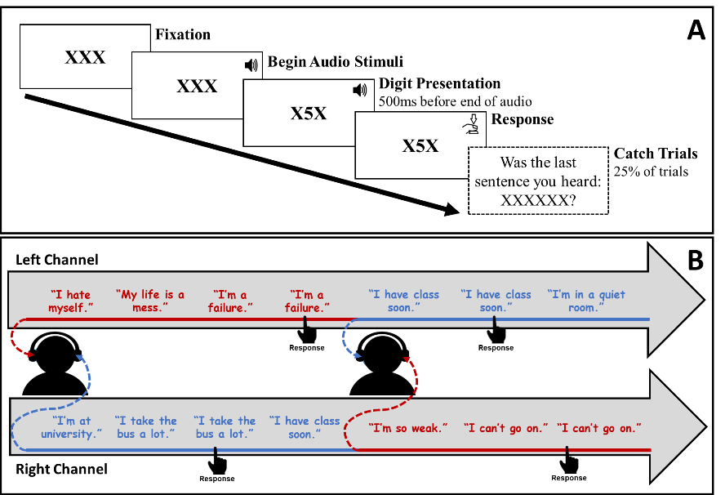

Second the **Mindful Awareness Task** (**MAT**) is a behavioral and phenomenological task to measure internal objects of mindful attention and awareness of mind, body and hedonic tone, as well as the time-course or temporal dynamics of mindful attention and awareness – during mindfulness meditation. Participants perform a 20-minutes mindfulness meditation (combined OM with FA) in which they are instructed (a) to monitor a wide range of prominent present moment experiences (e.g., sensations, emotions, thoughts), and (b) to direct their awareness to their breath when they do not notice any experience. To measure performance during the meditation, participants are instructed (a) to verbally state a label describing each experience they notice (e.g., “warm”, “calm”, “tension”, or “thinking”), and (b) to press a button when they notice their inhalation or exhalation. Accordingly, mindful awareness of body, mind, and pleasant and unpleasant hedonic tone are scored using manualized qualitative coding of the content of participant’s verbal labels (e.g., “warm” is coded as body, “calm” is coded as pleasant hedonic tone, “tension” is coded as unpleasant hedonic tone, and “thinking” is coded as mind). Afterwards, to quantify the time-course of mindful awareness, the precise timing and order of all reports of mindful awareness (i.e., labels and button presses) are analyzed to divide and classify the 20-minutes meditation into *mindful sequences* and *mindless sequences*. So doing yields a *sustained mindful awareness score* as well as a *latency to re-engagement in mindful awareness score*.

Critical to the proposed research, no study has yet tested the prospective sensitivity of the MAT to mindfulness intervention, and its association to other internal and interoceptive attention tasks measured by the STP integrated into several tasks, as we plan in the proposed research.

1. **MMT, body and interoceptive attention: Theory, empirical findings and emerging methods**

**Theory**

Attention to and awareness of bodily sensations has been conceptualized as both internal and external attention, depending on the applied taxonomy of attention (Chun et al., 2010; Dixon et al., 2014). Without seeking to reconcile this debate, we focus on attention to internal objects of experience, including bodily sensations, since they are the primary objects of attention when practicing MMT (Hadash & Bernstein, 2019).

In recent years, there has been a growing interest in study of bodily sensations and interoceptive awareness due to its relevance for understanding psychosomatic symptoms and mind-body interactions. Relatedly, sensations generated in the body are commonly classified as *interoceptive signals* (e.g., pain, temperature, itch, hunger) (Craig, 2003; Khalsa et al., 2018) whereas *interoceptive awareness* refers to *interoceptive features* accessible to conscious awareness. *Interoceptive features* entail *interoceptive attention*  to specific interoceptive signals, *interoceptive accuracy*or*sensitivity* whichrefers to the ability to accurately detect interoceptive signals (e.g., heartbeat detection)[3] and *interoceptive sensibility* which refers to the self-evaluated tendency to focus/note on interoceptive signals (Khalsa et al., 2018) .

Mindfulness training is thought to/ theorized to alter/impact interoceptive awareness, in that interoceptive attentional change processes such as selection tendencies to specific interoceptive signals (i.e. specific locations, intensities or hedonic tone), are expected to be reduced by MMT (N. Farb & Mehling, 2015) and thus promotes interoceptive sensitivity/accuracy (N. A. S. Farb, Segal, & Anderson, 2013b). MMT may also enable a shift from internal attention to the mental representation of emotions (mind) to interoceptive attention to the bodily-based representation of emotions (N. A. S. Farb et al., 2010; Garland, Gaylord, Mann, & Whitehead, 2012). Accordingly, interoceptive attention to subtle sensations should be regarded as an important mindfulness process (N. Farb & Mehling, 2015; Hölzel et al., 2011). In addition, the importance of mindful awareness to subtle bodily sensations is also emphasized in canonical and contemporary Buddhist traditions (Hart, 1987; Nielsen & Kaszniak, 2006; Zeng, Oei, & Liu, 2013).

**Findings**

Although most MMT-attention research has focused on external attention, some have explored interoceptive attention to bodily objects and other interoceptive features (for review see (N. Farb & Mehling, 2015; Treves, Tello, Davidson, & Goldberg, 2019). One set of studies focused on *interoceptive accuracy/sensitivity* and involves *objective measures* (i.e. third-person) of interoceptive signals in compared to subjective assessment (i.e. first-person) of those signals. The second set of studies is focused on *subjective and phenomenological assessment* (i.e. first-person) of interoceptive signals.

With respect to interoceptive accuracy/sensitivity in MMT studies, a major body of research was based on physiological markers (i.e. third-person), such as heartbeat detection and Respiratory Load Detection, while some have used experimental stimuli such as tactile stimuli (see meta-analysis: (Treves et al., 2019)).[4] Briefly, extant findings from Heartbeat Detection Tasks and Respiratory Load Detection studies provide limited support of the construct validity and known-group validity of these tasks as measures of mindfulness processes (Daubenmier, Sze, Kerr, Kemeny, & Mehling, 2013). Although, the Somatic Signal Detection Task demonstrated increased tactile accuracy following a body scan mindfulness practice (Mirams, Poliakoff, Brown, & Lloyd, 2013). Overall, those findings regarding interoceptive accuracy are mixed, and a clear conclusion regarding the utility of objective measures for understanding interoceptive attention in MMT is difficult to reach (Treves et al., 2019). Indeed, some of the null-effect may be explained by the fact that mindfulness practices do not involve any particular emphasis on the sensations associated, for example, with one’s heartbeat (Treves et al., 2019). MMT involves interoceptive attention to a wide array of bodily sensations (N. Farb & Mehling, 2015; Treves et al., 2019), but the science still has no objective measures for the dynamic nature of sensations in time and bodily-space. In addition, most of those studies refer to the physical aspect of the body, focusing on a specific and narrow interoceptive signal, as isolated from other sensations and far from the phenomenology of subjective feeling of bodily sensations. In order to detect the individual and dynamic phenomena of interoceptive attention in the context of MMT, novel subjective assessments have been developed.

Those included mostly measures of interoceptive attention to the breath, while there is also a preliminary attempt to explore interoceptive attention to other bodily sensations. Interoceptive attention to the breath during mindfulness meditation has been measured by several tasks utilizing real-time experience sampling (e.g. probe and self-caught) during focused attention meditation to the breath (for review: (Hadash & Bernstein, 2019), and one utilizing counting of breaths repeatedly (the Breath Counting Task(Levinson, Stoll, Kindy, Merry, & Davidson, 2014). The findings demonstrate that these tasks distinguish meditators from novices and are sensitive to change in the performance following mindfulness training (Levinson et al., 2014; Wong, Massar, Chee, & Lim, 2018). Yet, these tasks only measure attention to breath and do not capture other aspects of interoceptive attention in MMT. Therefore, a recent research developed a body map methodology to measure interoceptive attention to bodily sensation by a subjective reporting of sensations (Digital Sensation Manikin**[5]**), allowing participants to mark the location and hedonic tone (pleasant or unpleasant) of their sensations (Hanley & Garland, 2019). They found that the ratio of pleasant to unpleasant sensations significantly increased following mindfulness intervention among chronic pain patients, comparing to an active control condition. Still, this task is lacking an experimental manipulation of a specific emotional experience, thus the measurement is unable to detect within-participant change at the same experimental session. Moreover, the measure is not sensitive to the intensity of sensations, neutral hedonic tone (only pleasantness or unpleasantness) and to sensations in both sides of the body (front and back side). Previous study in the context of emotion research, utilized a similar body map methodology and measured the location and intensity of sensations in response to emotional stimuli and thus detected categorical sensations patterns of subjective feelings (Body Sensation Map,((L. Nummenmaa, Glerean, Hari, & Hietanen, 2013; Lauri Nummenmaa, Hari, Hietanen, & Glerean, 2018)). This finding emphasis the importance of using experimental emotional stimuli for evoking specific emotional state, while exploring interoceptive attention, due to the different bodily sensations pattern in different states..

Those figures are relevant?

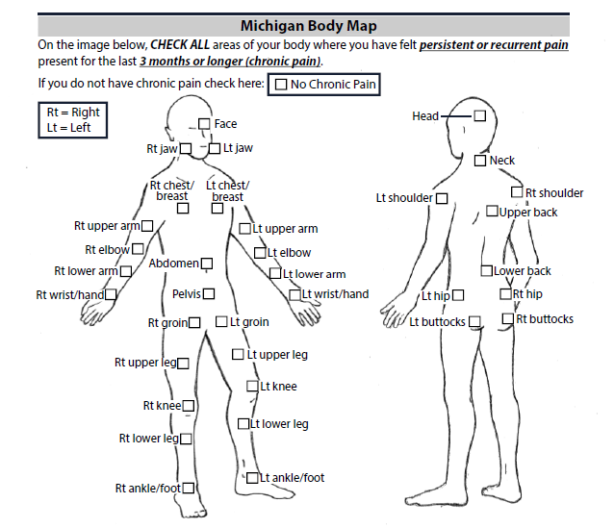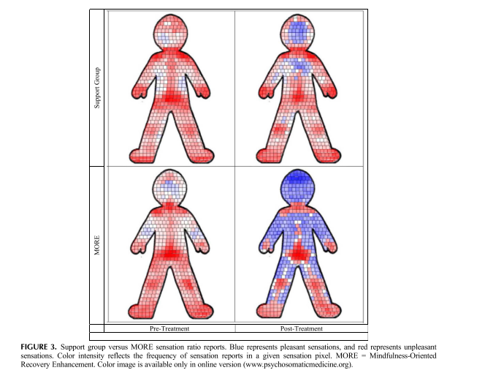 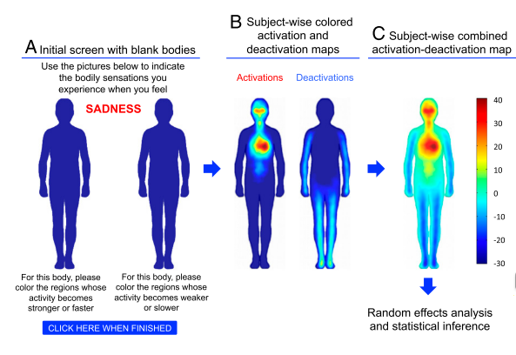

## **Emerging methods**

Despite the challenges of exploring interoceptive attention directly, there are some emerging methods and preliminary attempts to measure and quantify interoceptive attention broadly and in MMT specifically[6].

Supported by previous research (such as the Digital Sensation Manikin, Body Sensation Map), the body map methodology may be suitable to explore interoceptive attention to the location, intensity and hedonic tone of bodily sensations, following MMT, while measured in response to specific emotional stimuli. Combining those two existing body map methods and developing a new task that both experimentally controls for a specific emotional experience and collects more information about the sensations is one of the aims of the proposed research for exploring the phenomena of interoceptive awareness in MMT. In addition, the Mindful Awareness Task (MAT) (see section 5 above) is also relevant to interoceptive awareness of the breath and verbal representations of bodily sensations.

# **Conclusion**

Although attention has a definitive and functional role in MMT, the findings regarding attentional processes in MMT are mixed. It may be explained by the use of external objects of attention, in most of the studies which practically explored *external attention* processes in MMT (Chiesa et al., 2011; Lao et al., 2016; Malinowski, 2013; Y. Y. Tang et al., 2015; Vago et al., 2019). Buddhist and contemporary text and psychological models of attentional processes in MMT, highlight the role of attention toward internal objects, such as thoughts, bodily sensations and their hedonic tone during MMT. Indeed, studies which explored WM and mind wondering following MMT, provide indirect evidence for the role of *internal attention* to thoughts and mental objects during MMT. In addition, studies which explored body awareness and interoception following MMT, provide preliminary evidence for the role of *interoceptive attention* to bodily sensations, the feeling of breath and others interoceptive signals during MMT. In the proposed research, we aim to use the emerging method of the Simulated Thoughts Paradigm (STP), integrated into cognitive tasks for exploring internal attention, and integrated into new body map task, for exploring interoceptive attention. We also aim to use the Mindful Awareness Task (MAT) for exploring those attentional processes during mindfulness meditation.

# Methods

# **Proposed aims & study overview**

Thus, in the proposed dissertation research, we will work to better understand the discrepancy between theory regarding the essential role of attention change processes in MMT on the one hand with the extant limited and mixed empirical evidence of such effects on the other. To do so, we will test the key thesis of the proposed dissertation research. Specifically, whether focusing on attention to *internal* mental and bodily experiences (e.g., thoughts, body sensations), rather than on *external* environmental stimuli (e.g., visual attention), may help to advance understanding of the nature and function of attentional change processes in MMT and thereby help rectify the paradoxical discrepancy in extant science of mindfulness and attention (Chiesa et al., 2011; Cusens et al., 2010; Josefsson & Broberg, 2011).

To test this thesis, we propose to explore how a 7-day MMT retreat (N=80), relative to a wait-list control condition (N=40), will impact attention to *internal* experience, namely thoughts and bodily sensations, and how these internal attentional change processes will impact salutary outcomes, such as mental health and well-being, of the MMT retreat. Before and immediately following the retreat, the retreat group will complete tasks measuring internal and interoceptive attention. Among the wait-list control group, assessments will be administered at baseline and then again 7 days later – to parallel the timing of assessments pre- and post-retreat. We will also model the effect of previous experience in mindfulness meditation on predicted aims in pre-post and base-line measurement.

These tasks include: (i) digit-categorization using the Simulated Thought Paradigm (STP) to measure disengagement from negative self-referential thoughts, (ii) dichotic one-back using the STP to measure internal selection bias to negative self-referential thoughts, (iii) the body map using the STP to measure interoceptive attention to bodily sensations in response to negative self-referential thoughts, and (iv) the Mindful Awareness Task (MAT) to measure mindful awareness and attention to internal experiences during mindfulness meditation (see Sections 4 and 5 for review of these emerging methods). In addition, at baseline and then again 2-weeks post-retreat, participants will complete a brief battery of self-report questionnaires of outcomes that we expect will be impacted by the MMT retreat and specifically wellbeing and mental health outcomes that we expect to be more proximally influenced by theorized attentional change processes over the course of the retreat. Among the wait-list control group, the self-report battery will be administered at baseline and then again 2-weeks later.

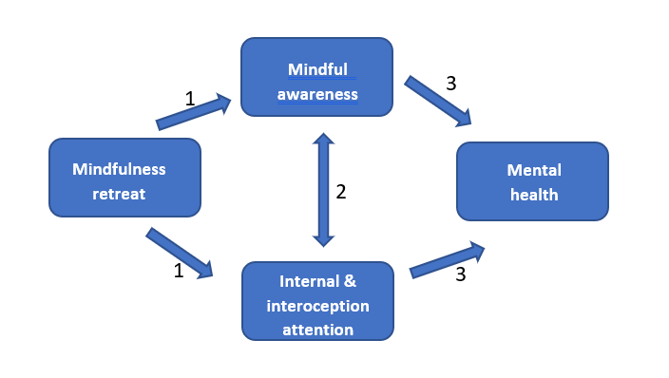

Another option for a chart –(including a separated aim 3 of mind-body interaction)

# 

# Specific Aims of Proposed Research

**Aim 1: Effects of intensive MMT on internal attention to thoughts and interoceptive attention to bodily sensations, during mindfulness mediation and in daily life**

We predict that relative to the wait-list control condition, the MMT retreat condition will demonstrate significant improvement at post- relative to pre-retreat in each of the following processes:

**(i)**  **Internal attention to thoughts in daily life.** (a) enhanced ability to disengage from negative self-referential thoughts, as quantified by the STP integrated into the Digit Categorization Task; as well as (b) reduced selection bias to negative self-referential thoughts, as quantified by the STP integrated into the Dichotic 1-back task. Indeed, MMT is expected to affect internal attentional control, which enables disengagement from negative thoughts as well as reduced selection of negative thoughts (Bishop et al., 2004; Chiesa et al., 2011; Functional, 2012; Hölzel et al., 2011; Lao et al., 2016; Lutz et al., 2015; Malinowski, 2013; Shapiro et al., 2006b; Y. Y. Tang et al., 2015).

**(ii)** **Interoceptive attention to bodily sensations in daily life.** (a) enhanced sensibility to a broader range of bodily locations, quantified by the STP integrated into the Body Map task as a greater overall number and range of bodily sensations in response to negative and neutral thoughts, including in peripheral bodily areas (e.g., arms, legs) as well as subtle sensations characterized by less intensity,; (b) enhanced sensibility to the intensities of sensations, quantified by the STP integrated into the Body Map task as a greater overall mean intensity of bodily sensations, and Increase in variance of intensities, in response to negative and neutral thoughts;(c) reduced selection bias to unpleasant sensations and enhanced sensibility to a broader range of sensations’ hedonic tone, quantified by the STP integrated into the Body Map task as a greater number and higher intensity of neutral and pleasant bodily sensations, in particular in response to neutral thoughts. Indeed, MMT is expected to promote sustained interoceptive attention, which reduces selection bias to specific locations and hedonic tone of sensation, such a broader range of sensations are expected to cross the threshold into conscious awareness (N. A. S. Farb et al., 2013b).

**(iii) Internal attention to mind and interoceptive attention to body during mindfulness meditation.** (a) enhanced mindful awareness of mental objects and bodily sensations during mindfulness meditation, quantified by MAT frequencies of verbal labels indicating awareness of internal objects; (b) enhanced awareness of pleasant hedonic tone of experience, as quantify by MAT frequencies of verbal labels indicating awareness of pleasant experiences (c) enhanced sustained mindful awareness and shorter latencies to reengage in mindful awareness following the onset of mindless states, as quantify by the MAT as durations of mindful and mindless sequences, respectively.

**Aim 2: Mindful attention and awareness during mindfulness meditation in relation to****Internal and interoceptive attention in daily life**

We predict that mindful attention and awareness during mindfulness meditation will be related to internal and interoceptive attentional processes in response to negative versus neutral thoughts in daily life. Thus, we predict the following correlations in baseline/pre-retreat measurements in both conditions (i.e., MMT retreat, wait-list control), and in pre-post retreat changes in MMT retreat condition:

**(i) Internal attention**. (a) selection bias to negative thoughts contents (STP & dichotic 1-back) will be related to increased mindful awareness of unpleasant experience during mindfulness meditation (MAT); Likewise, (b) impaired ability to disengage from negative thoughts (STP & DCT) will be related to longer latencies to disengage from mindless states and reengage in mindful awareness during mindfulness meditation (MAT). Indeed, selection bias to specific thoughts contents and attentional control which related to disengagement from negative thoughts are main attentional processes in mindfulness practices (Bishop et al., 2004; Chiesa et al., 2011; Functional, 2012; Hölzel et al., 2011; Lao et al., 2016; Lutz et al., 2015; Malinowski, 2013; Shapiro et al., 2006b; Y. Y. Tang et al., 2015).

**(ii) interoceptive attention.** (a)enhanced sensibility to bodily sensations in response to negative and neutral thoughts (STP & Body Map task), will be related to mindful awareness of bodily experiences during mindfulness meditation (MAT). (b) The prevalence of pleasant bodily sensations, in response to neutral thoughts (STP & Body Map task), will be related to mindful awareness of pleasant experiences during mindfulness meditation (MAT). Likewise, (c) the prevalence of unpleasant bodily sensations, in response to negative thoughts (STP & Body Map task), will be related to mindful awareness of unpleasant experiences during mindfulness meditation (MAT). , including the hedonic tone of bodily sensations and mental experiences (Analayo, 2019; Batchelor, 2019)

**Aim 3: mind-body interaction in daily life and during mindfulness meditation**

We predict that internal and interoceptive attentional processes and emotional reactivity to thoughts will be inter-related, in daily life and during mindfulness mediation. We predict the following correlations in all measurements in both conditions (i.e., MMT retreat, wait-list control):

**(i)** Difficulty to disengage from, and selection bias to negative thoughts, will be related to higher levels of emotional reactivity to negative thoughts (STP & emotions rating) and with impaired sensibility of bodily sensations in response to negative thoughts (STP & Body Map task), quantify by lower overall number of bodily sensations as well as mostly gross sensations characterized by high intensity and located mostly in central bodily areas (e.g., head, chest, stomach).Indeed, mental representation of negative emotions (e.g., subjective appraisals, ruminations) is usually more available to attention than sensory- based representation of emotions (e.g., fluctuations in body sensations, somatic signatures) (Khalsa et al., 2018). MMT is expected to reduce emotional reactivity by shifting attention away from mental representation of emotions in the mind, toward sensory- based representations of emotions in the body (N. A. S. Farb et al., 2010; Garland et al., 2012).

**(ii)** Mindful attention and awareness to bodily sensations during mindfulness meditation, as quantified by the frequency of verbal labels of bodily objects (MAT), is expected to be correlated with mindful attention and awareness to mind during mindfulness meditation, as quantify by the frequency of verbal labels of mental objects (MAT). Indeed, during MMT, bodily sensations provide a continuous cue for refocusing attention on internal experience, without mental appraisal and rumination (N. A. S. Farb et al., 2010).

**Aim 4: The effect of internal and interoceptive attention change processes on MMT curative outcomes**

Among participants in the MMT retreat condition, we expect that internal and interoceptive attention change processes in daily life and during mindfulness mediations from pre- to post-retreat (aim 1), will predict elevations in wellbeing and mental health outcomes from pre- to 2-weeks post-retreat, including:

**(i)** Elevated decentering (**Metacognitive Processes of Decentering Scale, CITE)**, meta-awareness (FFMQ, CITE) and emotional awareness (DERS-Lack of emotional awareness) as well as reduced mind wandering (**Mind Wandering Questionnaire)**,repetitive negative thinking (**Perseverative Thinking Questionnaire)** and self-referential negative thoughts (Automatic Thoughts Questionnaire).

**(ii)** Elevated well-being (**Well-Being Index, )** along with reduced anxiety (**OASiS, )** and depression (**PHQ-9, CITE)** symptoms.

**Participants**

We plan to recruit 90 participants to the mindfulness retreat group and 40 to wait-list control group (~50% female, ages 18-65). Sample size based on a power analysis to permit detection of effects of modest magnitude (*d* = .30). Participants will be recruited from people who are registered for mindfulness 7-days retreat of ‘Tovana’ organization. The retreat is open to the general community and based on donation (*dana),* permitting participation from a range of socio-economic means. Likewise, wait-list control participants will be recruited from people who are on Tovana’s wait-list for 7-days retreat.

The mindfulness meditation experience should vary from novice participants (expected to be at least 50% from the participants), experienced participant and a few experts mediators. The novice group will includes (a) no participation in one or more intensive 10 days (or longer) *Vipassanā*/insight meditation retreat; (b) having less than one year of experience in open monitoring (OM) mindfulness meditation (defined as attention to anything that occurs at the present moment in body and mind); (c) < 90-hrs of experience in daily OM mindfulness meditation (i.e. not during meditation courses; 90 hours is equivalent to practicing for 30 minutes a day, every other day, for one year); (d) practicing OM mindfulness meditation less than three times a week during the last two weeks. The rest, which are not novices, will be assign to the experiences group, and will have a phone interview for evaluation their level of expertise in mindfulness mediation.

**Inclusion/Exclusion Criteria.** Participants will be excluded from study if they are: (a) younger than 18 years-old; (b) diagnosed with ADD/ADHD, dyslexia, language disability or an autism spectrum disorder; (c) report hearing or speech difficulties due to methodological constraints of administered tasks; or (d) mother tongue other than Hebrew (to reflect their native internal language-of-thought), not fluent in Hebrew, or report thinking in a language other than Hebrew due to methodological constraints of administered tasks (i.e., STP);(e) uncorrected vision problems (i.e., no glasses or contact lenses despite impaired vision).

**Procedure**

Participants who registered to Tovana’s retreat, including to the retreat’s wait-list, will receive an email inviting them to participate in the study with a link to the study registration web-site. The registration web-site will include short explanations about two options of participation in the study – basic format included the MAT and questionnaires, and expanded format, included selection and recording of the STP stimuli at home and additional tasks before and after the retreat (see figure X for detailed procedure).

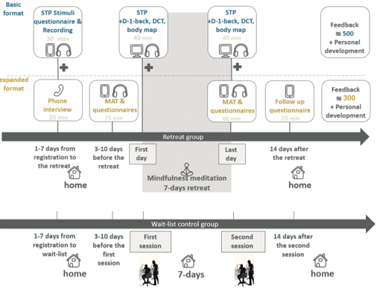

We plan to run about 7 to 8 waves of retreats, N=10-15 per retreat group. The 7-days mindfulness retreats will be organized by ‘Tovana’- the Israel Insight Meditation Society. The retreats are held in silence and led by senior teachers with many years of experience. Tovana’s retreats which are not 7-8 days, such as weekend retreats or more than 8 days retreats, will not be included in the study. In addition, Tovana’s speciel retreats, such as practice of non-dualism, *Anata* and *Meta* will not be included, only insight (*Vipassana*) mindfulness meditation 7-days retreats.

**Detailed procedure of the Expanded format of the study**

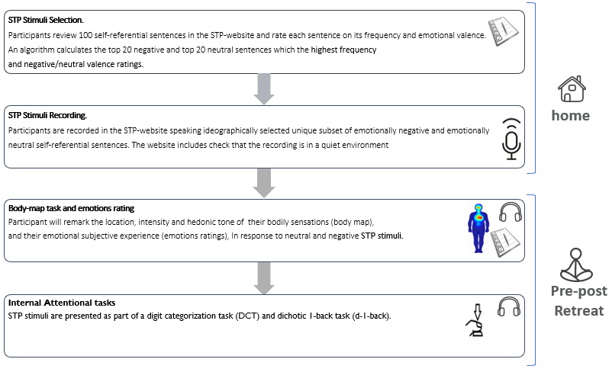

**Measures and apparatus**

## **Simulated thoughts paradigm (STP)**

The STP (see section 5 in the introduction) will be used as internal stimuli to measure internal attention in the Digit Categorization task and dichotic 1-back task and to measure interoceptive attention in the Body Map task.

**Idiographic stimuli selection and recording**. Participants will review via STP web-site a list of 100 self-referential verbal thought-like sentence items, of which 67 negatively valenced items (e.g., "I'm so alone.") were derived from established questionnaires[7] and 33 as emotionally neutral (e.g., "I have class soon."). Participants will rate (1) how *frequently* they have thoughts similar to each item, on a 5-point scale (1 = "Never have this thought" to 5 = "Think about it a lot"; (Hollon & Kendall, 1980)) and (2) to what *degree* the item/thought elicits negative or positive emotion on 7-point scale (*valence level*; -3 = "Very negative", 0 = "Neither positive nor negative", 3 = "Very positive."). For each participant, we will select the 20 negative self-referential items with highest frequency and negative valence ratings, and 20 neutral self-referential items with highest frequency and nearest to neutral valence (i.e., smallest absolute value; ratings (i.e., ratings nearest to 0). Participants will record their selected sentences at home via STP-website, using headphone microphones. These recordings will be used as simulated thought stimuli within the Digit Categorization tasks, Dichotic 1-back and Body Map task.

**Interoceptive attention to bodily sensations**

**Internal attention to thoughts**

## **Simulated Thought Paradigm: Digit categorization task (DCT)**

By integrating the STP into this adapted digit categorization task (Sudevan & Taylor, 1987)), we aim to measure attentional disengagement from stimulated thoughts (negative and neutral self-referential) to a digit categorization (odd or even) task (Sudevan & Taylor, 1987).

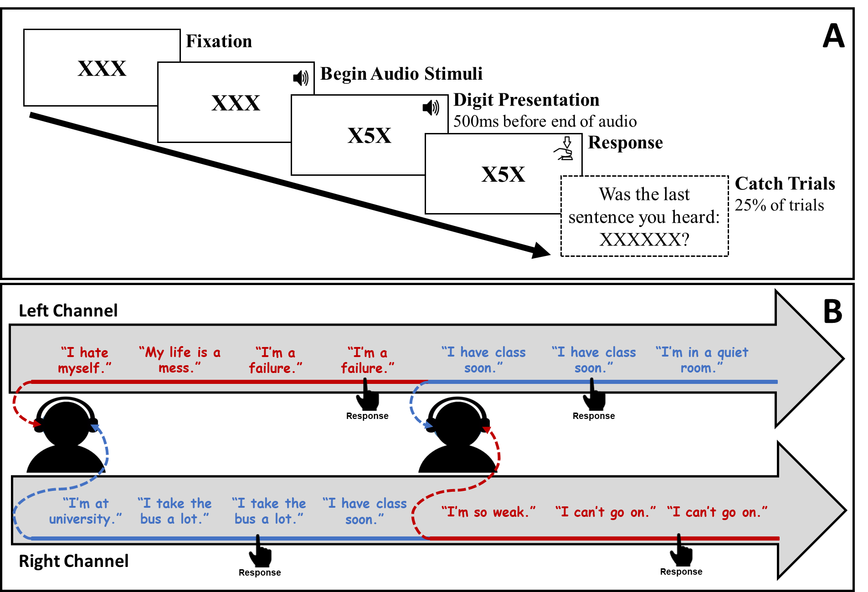

The task consists of 80 trials with trial type determined by the auditory stimulus (40 negative self-referential trials, 40 neutral self-referential trials; randomly presented). Each trial begins with three Xs (horizontally aligned) presented at the center of the screen. After 1000 ms, participants hear an auditory negative self-referential or neutral self-referential sentence. Five-hundred ms before the end of the auditory stimulus the central X is replaced by a single visual target stimulus digit number (from 1 to 8) until response. Participants are instructed to press one of two keys categorizing the target digit as odd or even. After response to the target digit participants are randomly (25% of trials) probed regarding the content of the sentence they heard during that trial. On 50% of catch-probe trials, the sentence presented (‘XXXXXX’ in the figure) was the same sentence heard, and on 50%, a different (incorrect) sentence was presented. The dependent measure is reaction time (RT), reflecting time to disengage from (negative and neutral self-referential) stimuli and respond to digit target.

## **Simulated Thought Paradigm: Dichotic 1-Back Task (D1B)**

This task is a novel integration of the established Dichotic Listening and 1-back experimental paradigms (Foa & McNally, 1986) designed to more closely reflect selective attention between concurrent thought-like stimuli.



The task consists of 3 blocks with a brief self-timed rest period between blocks. Participants hear two separate lists of auditory stimuli (STP), one list in each ear. Stimuli lists are randomly mixed into intra-block sequences (i.e., 12 STP stimuli/sequence) of negative or neutral self-referential thoughts. When one channel (e.g., left side) delivers a negative stimulus the opposite channel (i.e., right side) delivers a neutral stimulus. At pseudo-random intervals, the simulated thought stimulus in one of the channels is presented sequentially (i.e., specific STP recording is repeated). Participants are asked to, as accurately and quickly as possible, press one of two buttons corresponding to the channel (LEFT/RIGHT) in which the stimulus was repeated sequentially. Biased selective internal attention is computed by subtracting accuracy in responding to repetitions in neutral stimuli from accuracy in negative stimuli. A positive bias score reflects greater selective attention to negative vs. concurrent neutral stimuli.

## **Mindful Awareness Task (MAT)**

the Mindful Awareness Task (see section 5 in the introduction above) is a behavioral and phenomenological task for measuring internal attention and awareness during mindfulness meditation by measuring the objects and time-course of mindful awareness.

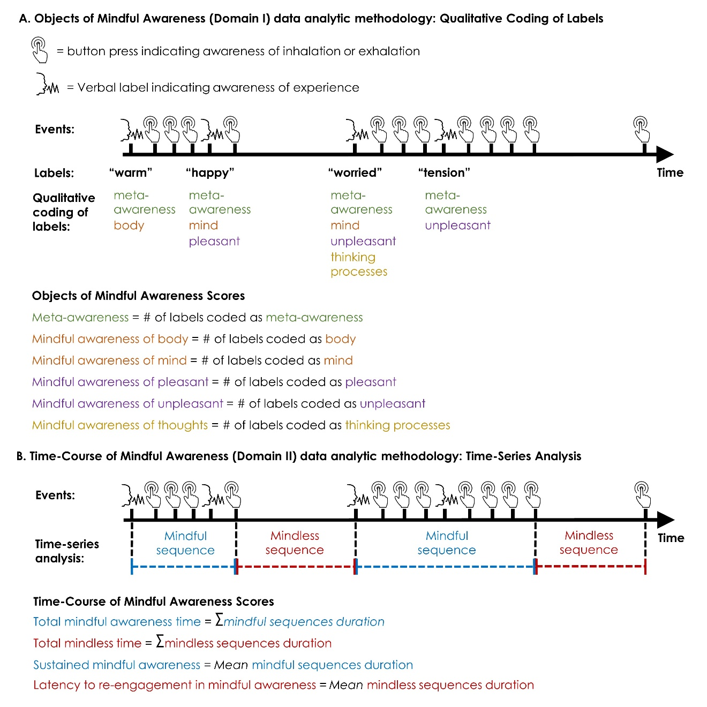Participants are instructed (a) to verbally state a label describing each experience they notice (e.g. ‘warm’, ‘calm’, ‘tension’, or ‘thinking’), and (b) to press a button when they notice their inhalation or exhalation (see Figure 2c). Mindful awareness of mind, body, pleasant and unpleasant hedonic tone mind are scored using manualized qualitative coding of the content of participant’s verbal labels (e.g. ‘warm’ is coded as body, ‘calm’ is coded as pleasant hedonic tone, ‘tension’ is coded as unpleasant hedonic tone, and ‘thinking’ is coded as mind). The number of labels referring to body, pleasant and unpleasant hedonic tone, and mind are summed to produce four individual difference scores reflecting mindful awareness of these experiential objects

To measure the time-course of mindful awareness, the MAT entails analysis of the timing and order of real time self-caught ES of mindful awareness during mindfulness practice to detect mindful and mindless time periods. The MAT applies this method to measure mindfulness processes expressed in time, as well as qualitative coding methods to measure the objects of mindful awareness. To quantify the time-course of mindful awareness, the precise timing and order of all reports of mindful aware- ness (i.e. labels and button presses) are analyzed to divide sequences in the 20-min meditation (see Figure 2c).

The MAT sustained mindful awareness and latency to re-engagement in mindful awareness scores display good internal consistency (split-half reliabilities mean rSpearman-Brown corrected = 0.83), construct validity (e.g. associations with retrospective ES measuring sustained mindful awareness and latency to re- engagement in mindful awareness, and a visual sustained attention task score), known-groups validity (i.e. distinguishing mindfulness meditators from non-meditators), and incremental validity (i.e. predicting key criterion variables beyond self-report measures of mindfulness; Y Hadash et al., presentation in International Symposium for Contemplative Research, Phoenix AZ, November 2018).

## **Simulated Thought Paradigm: Body map task**

By integrating the STP into a new Body Map task, we aim to measure sensibility to the location, intensity and hedonic tone of bodily sensations, as well as subjective emotional reactivity, in response to negative versus neutral self-referential thoughts.

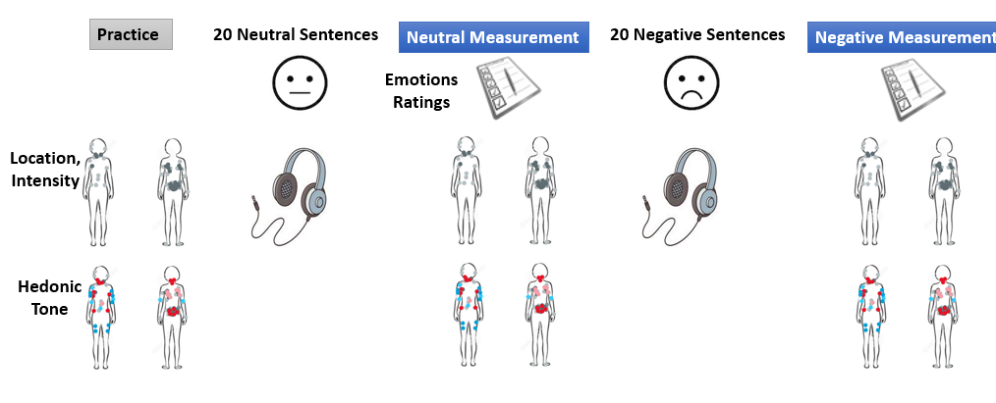

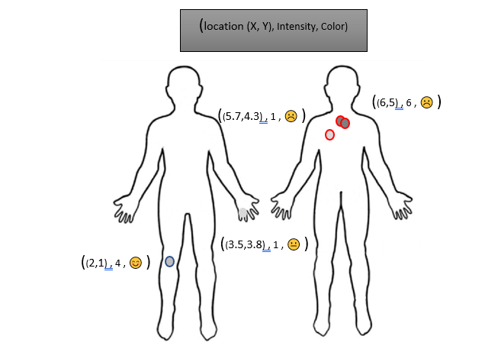

The task consists of two repeated measurements: (1) following neutral self-referential simulated thoughts (20 neutral simulated thoughts), (2) following negative self-referential simulated thoughts (20 negative simulated thoughts). Participants will be instructed to listen to the simulated thought stimuli “as if they were thoughts passing through your mind”. Each of the two measurements (i.e. neutral and negative measurement) entails three stages. Each measurement has three stages. First, participants will report on their subjective positive and negative affect by questionnaire (Subjective Emotional State; see Questionnaires below), as a measure of emotional reactivity to the simulated thoughts. Second, participant will report on the locations and intensities of their bodily sensations, without classifications the sensations into verbal categories. In this stage, the participants will be asked to mark the bodily sensation they feel in the present moment using mouse-clicks on 2D front and back silhouettes of a human body. The painting will be dynamic, enable to report on the intensity of each sensation by repeated clicks on a specific location, which will increase the opacity of the circle which represent a discrete/unique sensation. Third, participant will report on the hedonic tone of bodily sensations (i.e., neutral, pleasant and unpleasant). In this stage, participants will be asked to report about the hedonic tone of each of the reported sensation, using mouse-clicks which change the outline color of each sensation (blue = pleasant, yellow = neutral, red = unpleasant). During this stage, the participant can add new sensations or increase the intensity of sensations, similar to step 2. The diameter of the painting tool will set to 12 pixels. Finished images will be stored in matrices where both the front and the back of the body will be represented by 50,364 pixels (maximum drawing height, 163 pixels; width, 502 pixels) (Nummenmaa, Glerean, Hari, & Hietanen, 2013).

The data from all tasks will be coded by python 3.2 and the data will be acquired by laptops (Dell xxx).

## **Self-report questionnaires**

Self-report questionnaires will include mental health-related measures of decentering (**Metacognitive Processes of Decentering Scale, CITE)**, meta-awareness (FFMQ, CITE) and emotional awareness (DERS-Lack of emotional awareness),mind wandering (**Mind Wandering Questionnaire)**, repetitive negative thinking (**Perseverative Thinking Questionnaire)** and self-referential negative thoughts (**Automatic Thoughts Questionnaire**).

Mental health will be assessed by self-report questionnaire of well-being (**Well-Being Index)** as well as symptoms levels of anxiety (**OASiS)** and depression (**PHQ-9)**.

Negative and positive emotional reactivity will be assessed by subjective positive and negative affect ratings (Subjective Emotional States (SES) 103) following STP.

**Data analytic plan**

1. There is no clear consensus about how attention and memory should be optimally classified, and others argue that simple and complex span tasks largely measure the same basic processes (Unsworth & Engle, 2007), but exhaustive overview of cognitive functions is out of the aims and possibilities of the present work.
2. We provide more details for the more relevant methods.
3. Interoception constructs have varied definitions, while Interoceptive accuracy is referred also as interoceptive sensitivity (HADASH, 2013; Hadash & Bernstein, 2019; Kleckner et al., 2015)
4. We do not review neuroimaging (e.g.,fMRI, (N. A. S. Farb, Segal, & Anderson, 2013a; N. Farb & Mehling, 2015; Logie, 2018), since the current state of science does not provide a sufficient specific and reliable evidence about the attended interoceptive signals (Van Dam et al., 2018).
5. The SM based on others body map for pain measurement (e.g, Michigan Body Map, (Brummett et al., 2016)) aiming to develop a new tool for measuring physical pain.
6. We provide more details for the more relevant methods.
7. The Beck Depression Inventory II (BDI-II; Beck, Steer, & Garbin, 1998) Rumination Response Scale (RRS; Treynor, Gonzalez, & Nolen-Hoeksema, 2003) and the Automatic Thoughts Questionnaire (ATQ; Hollon & Kendall, 1980)